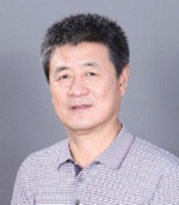
Title: Automatic Determination of Multi-Layer Perception Neural Net Structure with Pseudoinverse Learning Algorithm (3 hours)
Speaker: Prof. Ping Guo
Affiliation: School of Systems Sciences, Beijing Normal University, Beijing, China
E-mail: pguo@bnu.edu.cn

Abstract:
This tutorial includes the following objectives:
- Provide attendees with understanding of multi-layer perception (MLP) and stacked auto-encoders neural networks;
- Introduce one of the non-gradient descent algorithm – PseudoInverse Learning (PIL) algorithm;
- Learn how to choose the number of layer (deep) and hidden neuron (wide) of MLP neural networks;
- Understand the “divide and conquer” strategy for large scale data sets.

Bio:

Ping Guo, IEEE and CCF Senior member, Professor of School of Systems Sciences at Beijing Normal University, PhD student advisor of School of Computer Science at Beijing Institute of Technology, director of Image Processing & Patter Recognition Lab at Beijing Normal University, IEEE CIS Beijing Chapter Chair（2015-2016）. His research interesting includes computational intelligence theory and applications to pattern recognition, image processing, software reliability engineering, Astronomical big data analysis etc. He has published over 300 papers, two books entitled “Computational intelligence in software reliability engineering” and “Image semantic analysis”, respectively. He is also received Science & Technology Award of 2012 Beijing Peoples’ Government in “Studies of Regularization Method and their Applications”. (Third Rank).

Dr. Ping Guo got his Master degree in optics from the Department of physics at Peking University, and the Ph. D. in computer science at the Chinese University Hong Kong.

